**Practical No: 04**

**Aim: Create and design a page in WordPress.**

Step 1: login as Admin at WordPress.

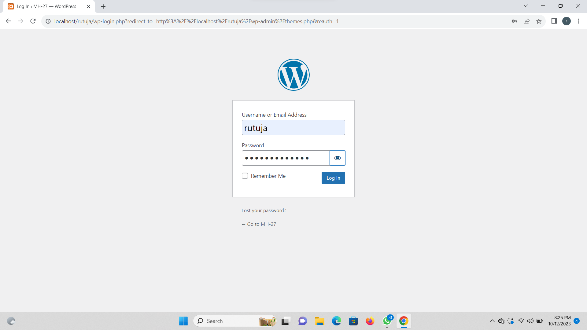

Step 2: select pages option and add new page.

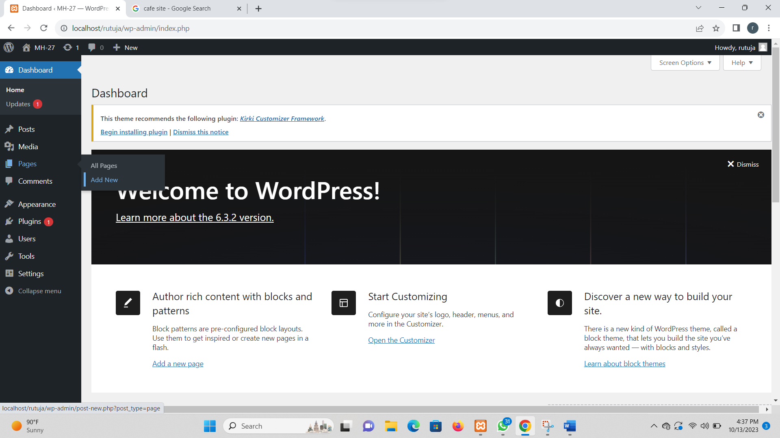

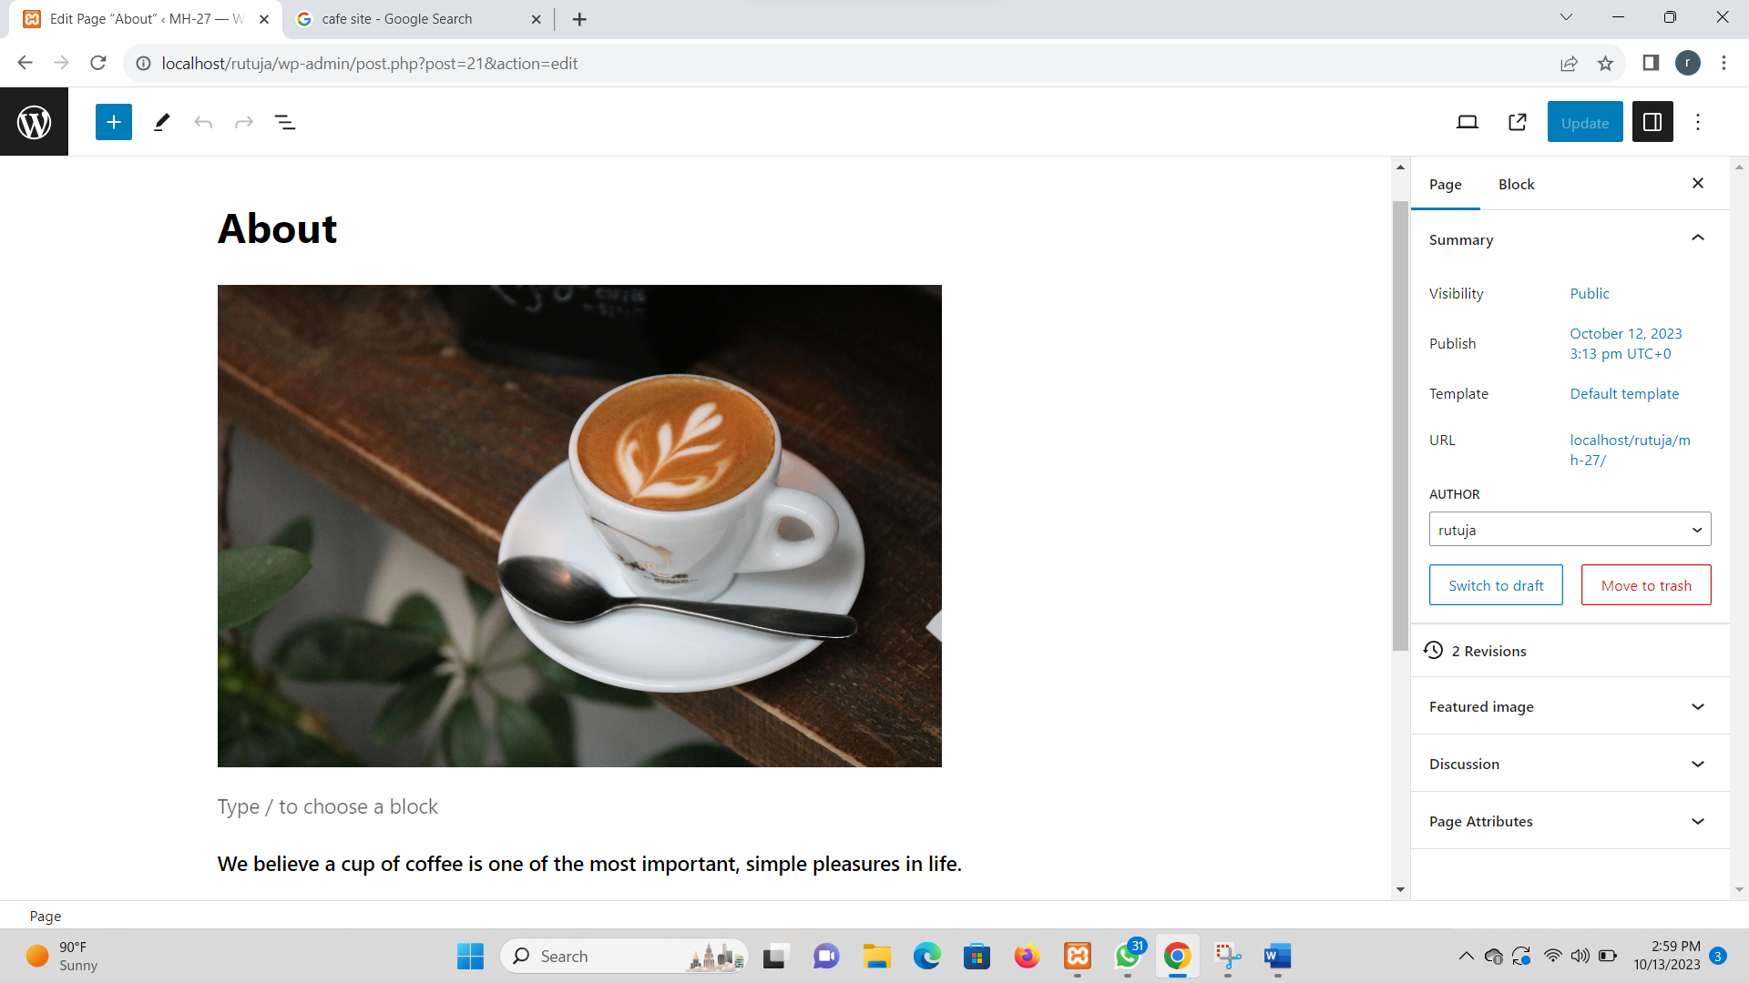

Step 3: find the pages menu in the WordPress dashboard navigation menu, click add new and add page title.

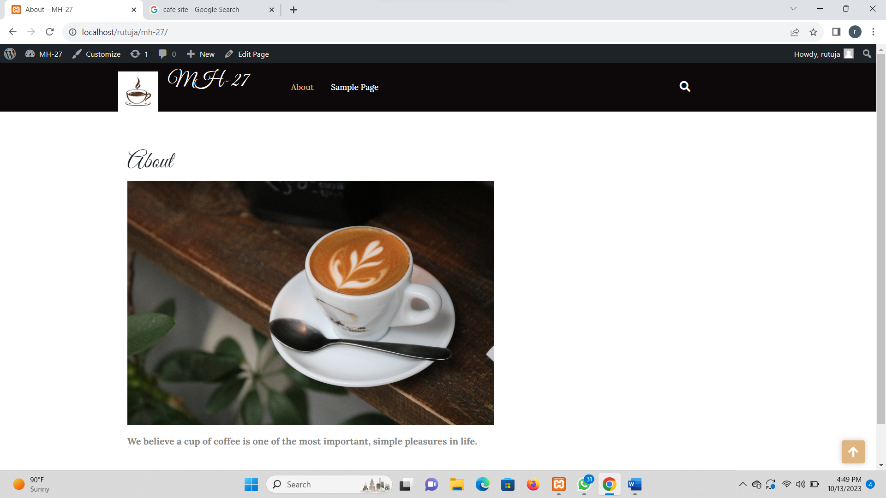

Step 4: add page menu.

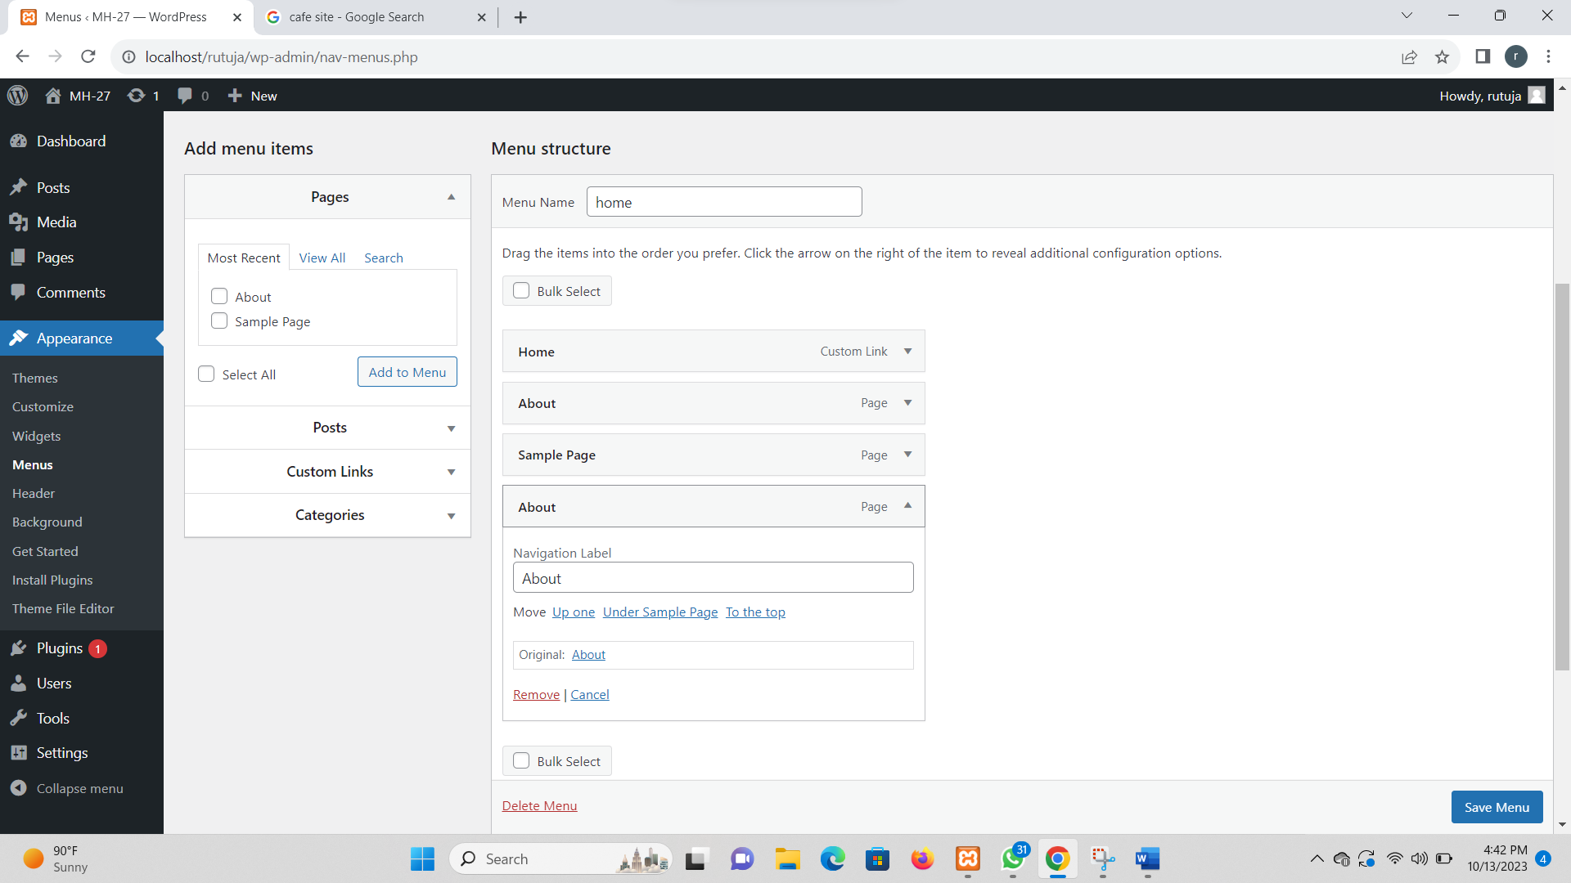

Step 5: front end.

